Commits

What Are Commits in Version Control?
# Source: AI Source: Provided by: [Data Path: Persons Table -> ID Column: 1, Name_En Column: Motasem Essam] -> From: [ChatGPT] on [2/15/2026]
A commit is like a snapshot of your project at a specific point in time. It records the state of your files from the Staging Area and saves it permanently in the Git repository.
Think of it as “saving your project with a timestamp and a note about what changed.”

Simple analogy
# Source: AI Source: Provided by: [Data Path: Persons Table -> ID Column: 1, Name_En Column: Motasem Essam] -> From: [ChatGPT] on [2/15/2026]

- Imagine your project is a document you’re writing.
- Each time you press Save, Git takes a snapshot of what you staged.
- You can go back to any snapshot later.

What a commit contains
# Source: AI Source: Provided by: [Data Path: Persons Table -> ID Column: 1, Name_En Column: Motasem Essam] -> From: [ChatGPT] on [2/15/2026]
- Snapshot of files → exactly what was staged
- Commit message → describes changes, e.g., "Add login feature"
- Author info → who made the commit
- Timestamp → when the commit was made
- Parent commit reference(s) → links to previous commits (history chain)

Initial Commit

What is Initial Commit
# Source: AI Source: Provided by: [Data Path: Persons Table -> ID Column: 1, Name_En Column: Motasem Essam] -> From: [ChatGPT] on [2/15/2026]
The initial commit is the very first commit made in a Git repository.
It’s special because it has no parent commit — there’s nothing before it. Think of it as the starting point of your project’s history.

Key points about Initial Commit
# Source: AI Source: Provided by: [Data Path: Persons Table -> ID Column: 1, Name_En Column: Motasem Essam] -> From: [ChatGPT] on [2/15/2026]
- First snapshot
  - It captures the initial files you want to track in the repository.
  - Usually includes a README.md, .gitignore, or basic project files.
- No parent
  - Unlike all later commits, it does not reference any previous commit.
- Foundation of Git history
  - All future commits will trace back to the initial commit through their parent links.

Example
# Source: AI Source: Provided by: [Data Path: Persons Table -> ID Column: 1, Name_En Column: Motasem Essam] -> From: [ChatGPT] on [2/15/2026]
- Start a new project:
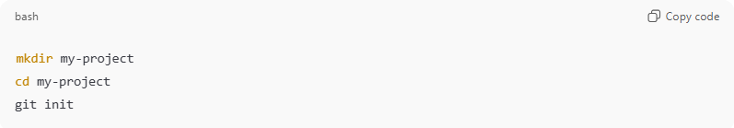
mkdir my-project
cd my-project
git init
- Add a README:
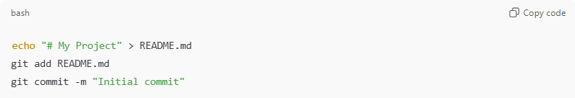
echo "# My Project" > README.md
git add README.md
git commit -m "Initial commit"
- This creates the initial commit, storing a snapshot of README.md.
- Parent commit = none

Quick analogy
# Source: AI Source: Provided by: [Data Path: Persons Table -> ID Column: 1, Name_En Column: Motasem Essam] -> From: [ChatGPT] on [2/15/2026]
- Initial commit = the “birth certificate” of the repository
- All other commits are “children” or “descendants” linked through parent commits

Key Visual
# Source: AI Source: Provided by: [Data Path: Persons Table -> ID Column: 1, Name_En Column: Motasem Essam] -> From: [ChatGPT] on [2/15/2026]
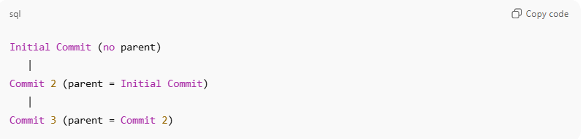
Initial Commit (no parent)
|
Commit 2 (parent = Initial Commit)
|
Commit 3 (parent = Commit 2)

💡 Memory trick:
# Source: AI Source: Provided by: [Data Path: Persons Table -> ID Column: 1, Name_En Column: Motasem Essam] -> From: [ChatGPT] on [2/15/2026]
Initial commit = first snapshot → no parent → start of history

Parent Commit

What is Parent Commit
# Source: AI Source: Provided by: [Data Path: Persons Table -> ID Column: 1, Name_En Column: Motasem Essam] -> From: [ChatGPT] on [2/15/2026]
A parent commit is the commit that comes immediately before another commit in the Git history. It’s like a link to the previous snapshot.
Every commit (except the very first one) has at least one parent commit, which allows Git to build a chain of commits — the project’s history.

How it works
# Source: AI Source: Provided by: [Data Path: Persons Table -> ID Column: 1, Name_En Column: Motasem Essam] -> From: [ChatGPT] on [2/15/2026]
- When you make a commit, Git stores:
  - Snapshot of staged files
  - Metadata (author, timestamp, message)
  - Pointer to parent commit(s)
- This pointer connects commits in a timeline.
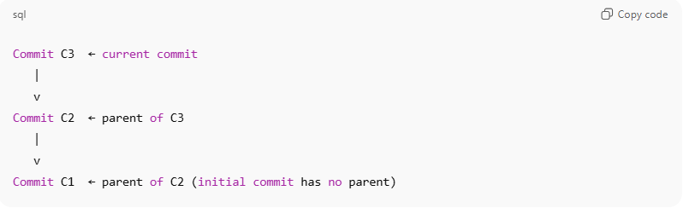
Commit C3 ← current commit
|
v
Commit C2 ← parent of C3
|
v
Commit C1 ← parent of C2 (initial commit has no parent)
- Initial commit: has no parent because nothing came before it.
- Merge commits: can have two or more parents, connecting multiple branches.

Example
# Source: AI Source: Provided by: [Data Path: Persons Table -> ID Column: 1, Name_En Column: Motasem Essam] -> From: [ChatGPT] on [2/15/2026]
- Initial commit:
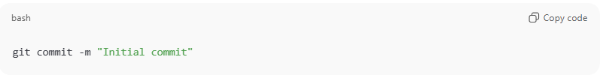
git commit -m "Initial commit"
- No parent → first commit
- Second commit:
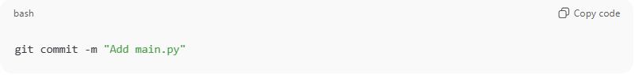
git commit -m "Add main.py"
- Parent commit = "Initial commit"
- Git stores a pointer to the first commit

- Third commit:
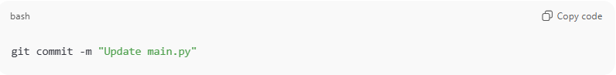
git commit -m "Update main.py"
- Parent commit = "Add main.py"
- Git can traverse backward through parents to see full history

Key Points
# Source: AI Source: Provided by: [Data Path: Persons Table -> ID Column: 1, Name_En Column: Motasem Essam] -> From: [ChatGPT] on [2/15/2026]
- Parent commit = the previous commit Git uses to build history
- Enables commands like:
  - git log → see history
  - git diff <parent> → see changes compared to parent
  - git checkout <parent> → go back to previous commit
- Merge commits can have multiple parents because they combine two branches.

💡 Memory trick:
# Source: AI Source: Provided by: [Data Path: Persons Table -> ID Column: 1, Name_En Column: Motasem Essam] -> From: [ChatGPT] on [2/15/2026]
Commit = snapshot + pointer to parent
“Parent commit” = the previous snapshot in the chain

How it works in workflow
# Source: AI Source: Provided by: [Data Path: Persons Table -> ID Column: 1, Name_En Column: Motasem Essam] -> From: [ChatGPT] on [2/15/2026]
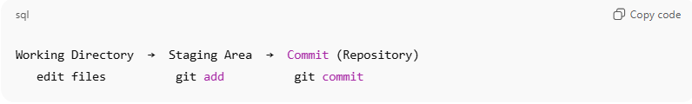
Working Directory → Staging Area → Commit (Repository)
edit files git add git commit
Step by step:
- You edit files in the Working Directory
- You stage changes using git add
- You commit staged changes:
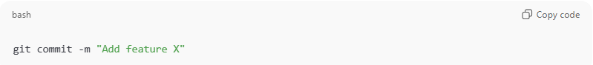
git commit -m "Add feature X"
Result: Git permanently stores a snapshot in the repository.

Important points
# Source: AI Source: Provided by: [Data Path: Persons Table -> ID Column: 1, Name_En Column: Motasem Essam] -> From: [ChatGPT] on [2/15/2026]
- Commits are permanent records in Git (unless explicitly deleted)
- Each commit has a unique ID (hash)
- Commits form a timeline (history) of your project
- You can revert, compare, or move between commits

Quick comparison
# Source: AI Source: Provided by: [Data Path: Persons Table -> ID Column: 1, Name_En Column: Motasem Essam] -> From: [ChatGPT] on [2/15/2026]
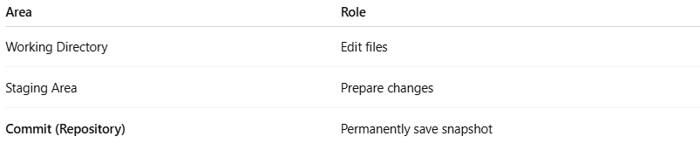
Area | Role
Working Directory | Edit files
Staging Area | Prepare changes
Commit (Repository) | Permanently save snapshot

💡 Memory trick:
# Source: AI Source: Provided by: [Data Path: Persons Table -> ID Column: 1, Name_En Column: Motasem Essam] -> From: [ChatGPT] on [2/15/2026]
- Working Directory = edit
- Staging Area = choose
- Commit = save forever ✅

